Dynamic Host Configuration Protocol (DHCP)/Bootstrap Protocol (BootP)
Dynamic Host Configuration Protocol (DHCP) assigns IP addresses to hosts. It allows easier administration and works well in small to even very large network environments. All types of hardware can be used as a DHCP server, including a Cisco router.
DHCP differs from BootP in that BootP assigns an IP address to a host but the host’s hardware address must be entered manually in a BootP table. You can think of DHCP as a dynamic BootP. But remember that BootP is also used to send an operating system that a host can boot from. DHCP can’t do that.
But there is a lot of information a DHCP server can provide to a host when the host is requesting an IP address from the DHCP server. Here’s a list of the information a DHCP server can provide
- IP address
- Subnet mask
- Domain name
- Default gateway (routers)
- DNS server address
- WINS server address
A DHCP server can give us even more information than this, but the items in the list are the most common.
A client that sends out a DHCP Discover message in order to receive an IP address sends out a broadcast at both layer 2 and layer 3.
- The layer-2 broadcast is all Fs in hex, which looks like this: FF:FF:FF:FF:FF:FF.
- The layer-3 broadcast is 255.255.255.255, which means all networks and all hosts.
DHCP is connectionless, which means it uses User Datagram Protocol (UDP) at the Transport layer, also known as the Host-to-Host layer, which we’ll talk about next.
In case you don’t believe me, here’s an example of output from my trusty analyzer:
Ethernet II, Src: 0.0.0.0 (00:0b:db:99:d3:5e),Dst: Broadcast(ff:ff:ff:ff:ff:ff)
Internet Protocol, Src: 0.0.0.0 (0.0.0.0),Dst: 255.255.255.255(255.255.255.255)
The Data Link and Network layers are both sending out “all hands” broadcasts saying, “Help—I don’t know my IP address!”
Broadcast addresses will be discussed in more detail at the end of this chapter.
Figure 3-3 shows the process of a client/server relationship using a DHCP connection.
Figure 3-3: DHCP client four-step process
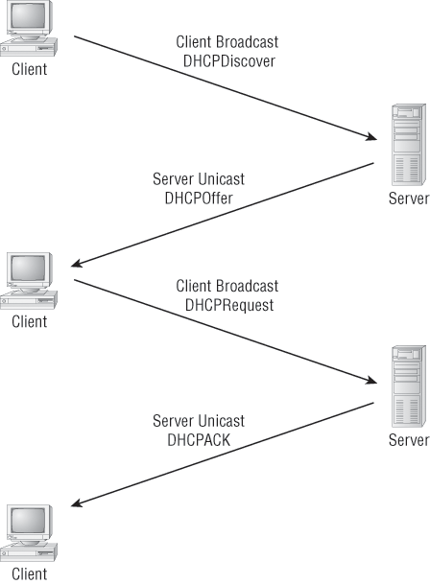
The following is the four-step process a client takes to receive an IP address from a DHCP server:
1. The DHCP client broadcasts a DHCP Discover message looking for a DHCP server (Port 67).
2. The DHCP server that received the DHCP Discover message sends a unicast DHCP Offer message back to the host
3. The client then broadcasts to the server a DHCP Request message asking for the offered IP address and possibly other information.
4. The server finalizes the exchange with a unicast DHCP Acknowledgment message.

DHCP Conflicts
A DHCP address conflict occurs when two hosts use the same IP address. This sounds bad, doesn’t it? Well of course it is! We’ll never even have to discuss this problem in my IPv6 chapter!
During IP address assignment, a DHCP server checks for conflicts using the ping program to test the availability of the address before it is assigned from the pool. If no host replies, then the DHCP server assumes that the IP address is not already allocated. This helps the server know that it is providing a good address, but what about the host? To provide extra protection against the all-so-terrible IP conflict issue, the host can broadcast for its own address.
A host uses something called a gratuitous ARP to help avoid a possible duplicate address. The DHCP client sends an ARP broadcast out on the local LAN or VLAN using its newly assigned address to solve conflicts before they occur.
So, if an IP address conflict is detected, the address is removed from the DHCP pool (scope), and it is all-so-important to remember that the address will not be assigned to a host until the administrator resolves the conflict by hand.
Please see Chapter 6 to see a DHCP configuration on a Cisco router and also to find out what happens when a DHCP client is on one side of a router and the DHCP server is on the other side (different networks)!

Broadcast DomainHere’s the written definition: Broadcast domain refers to a group of devices on a network segment that hear all the broadcasts sent on that network segment.Even though a broadcast domain is typically a boundary delimited by physical media like switches and routers, it can also reference a logical division of a network segment where all hosts can reach each other via a Data Link layer (hardware address) broadcast.That’s the basic story, so now let’s take a look at a collision detection mechanism used in half-duplex Ethernet.

